What to do with the Dry Start? From Greg Easton

 | LRZ North | LRZ South | MRZ North | MRZ South | HRZ North | HRZ South
Early June
Canola Not Sown | Stop Sowing | Stop Sowing | Stop Sowing | Stop Sowing | Stop Sowing | Stop Sowing
Canola Sown | >25mm Wait <10mm Consider Fallow | >25mm Wait <10mm Consider Fallow | >25mm Wait <10mm Consider Re Sowing to Barley | Wait | Wait | Wait
Legumes | Stop Sowing | Stop Sowing | Stop Sowing | Stop Sowing | Stop Sowing | Stop Sowing
Wheat | Consider Fallow | Consider Fallow | Continue Leave out heavy and shallow soils | Continue | Continue | Continue
Barley | Consider Fallow | Consider Fallow | Continue Leave out heavy and shallow soils | Continue | Continue | Continue
Late June
Canola Not Sown | Stop Sowing | Stop Sowing | Stop Sowing | Stop Sowing | Stop Sowing | Stop Sowing
Canola Sown | Consider Fallow | Consider Fallow | Consider Re=sowing to Cereals | Consider Re=sowing to Cereals | Consider Re=sowing to Cereals | Wait
Legumes | Stop Sowing | Stop Sowing | Stop Sowing | Stop Sowing | Stop Sowing | Stop Sowing
Wheat | Consider Fallow | Consider Fallow | Consider short season Barley or wheat/Fallow | Continue Leave out heavy and shallow soils | Continue | Continue
Barley | Consider Fallow | Consider Fallow | Consider short season wheat or barley | Continue Leave out heavy and shallow soils | Continue | Continue

I realise the dry start has not made seeding easy for many and many of you are considering what to do with the remaining seeding program especially with no significant rainfall predicted before the end of the first week in June.

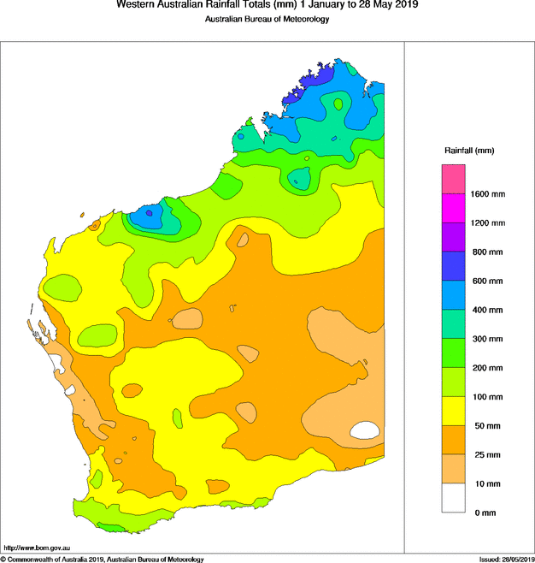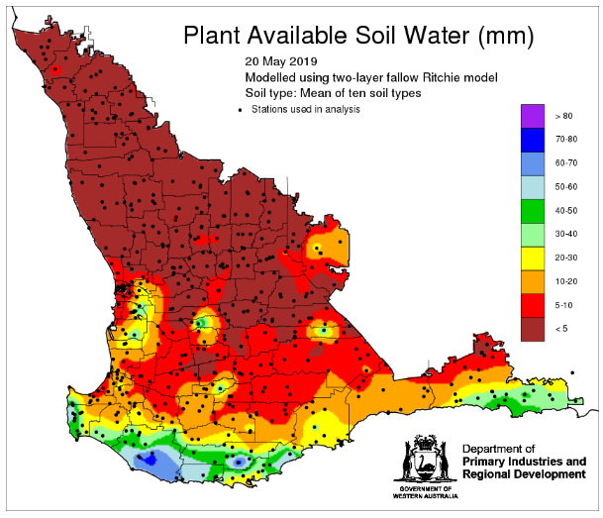

With low levels of subsoil moisture different decisions will be made depending on soil type.

Heavy soils will take more moisture to wet up and provide plant available water, whereas lighter soil types will require less water to wet and grow a crop. The fallow charts and tables highlight the water storage capacity of different soil types and rainfall required to germinate a sown crop.

Large areas of the state have <5mm of stored soil water and which means soils stronger than a loam will require at least 20mm to get to lower storage limit.

Remembering that any seeding operation with tynes is likely to cause a loss of up to 5mm (and if hot and windy 10mm) of any stored water.

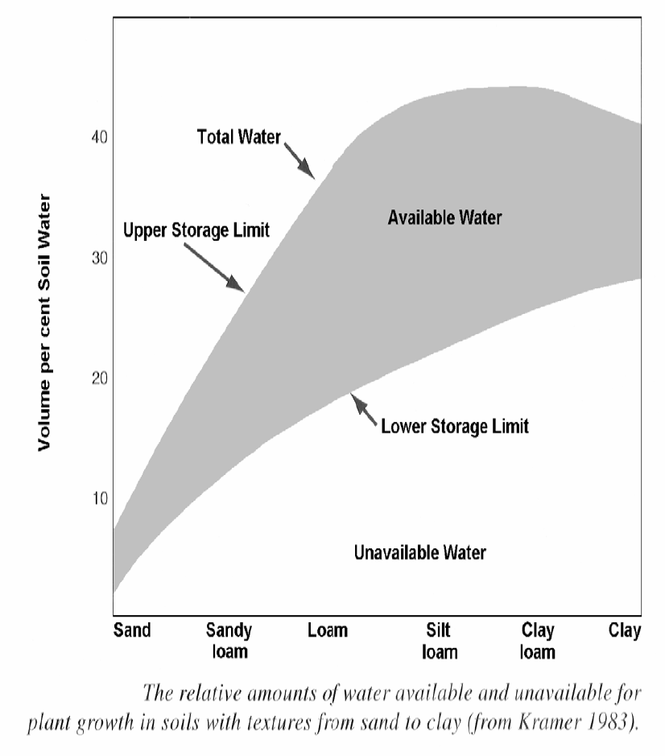
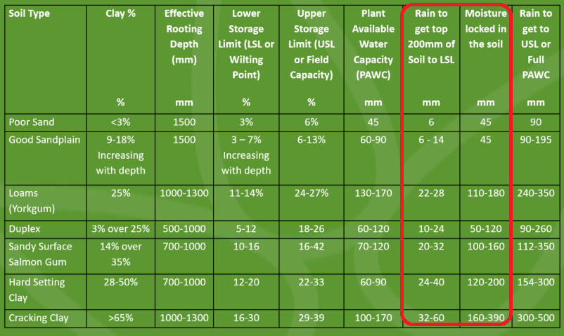
Clay soils in the LRZ are not going to receive enough water to satisfy the soil let alone grow a crop. These soils are best fallowed.
Soils in rainfall environments which can achieve a “full bucket” or Full PAWC, can yield well. The economics associated with having a crop in a low production year become more favourable as price tends to increase.

When faced with an adverse season all decisions fall back to two broad principles
- My business is under financial pressure and therefore all decisions are based on the cash impact on the business
  - Is the decision I am making today going to generate a Cash Margin because generating a Cash Margin will have a positive impact on your business.
  - All costs already incurred are sunk costs, therefore the decision is “Will the next cost improve the outcome by more than the cost?”
- My business is in a strong position and therefore decisions can be based on a profit basis and should include the deprecation cost of machinery, and taken into account future rotational benefits.

At the start of the season and before you sow the crop your cash margin is equal to your gross margin. To calculate the gross margin you calculate income and then deduct variable costs as demonstrated in the following table Using 2017 Profit Series Averages.

 | L | M | H
Wheat Yield | 1.63 | 2.48 | 3.21
Farm Gate Wheat Price | $255 | $255 | $255
Gross Income | $415 | $632 | $818
Wages | 12 | 24 | 34
Fertiliser | 67 | 100 | 129
Pesticide | 58 | 75 | 84
F&O | 22 | 27 | 30
R&M | 27 | 38 | 44
Seed | 22 | 26 | 33
Contract | 21 | 36 | 52
Other | 12 | 18 | 25
Total Variable Costs | 241 | 344 | 431
Gross Margin | $174 | $288 | $387

With variable cost calculated then a breakeven yield to cover variable costs can also be calculated.

In the above example you divided the Total Variable Costs by the Farm Gate Price and are tabled below in $20 increments.

 | L | M | H
Farm Gate Price | $255 | $255 | $255
Break Even Yield T/Ha | 0.95 | 1.35 | 1.69

 | L | M | H
Farm Gate Price | $275 | $275 | $275
Break Even Yield T/Ha | 0.88 | 1.25 | 1.57

 | L | M | H
Farm Gate Price | $295 | $295 | $295
Break Even Yield T/Ha | 0.82 | 1.17 | 1.46

If you have already sown the crop, then your cash margin should only include the variable costs from now on.

So, what does that mean for cropping programs from this point forward?

Canola

We learnt in2017 that canola does not perform well in dry years and that was again confirmed in 2018 and that late established canola doesn’t yield so well even with the soft finish, on average canola did not perform anywhere near as well as wheat.

A broad rule of thumb for lupins that can also be used for canola is that you need 200mm of Effective Rainfall for canola and lupin yields to cover variable costs and for wheat 190mm of Effective Rainfall to cover costs.

If using the guide of 0.50 t/ha of canola yield for breakeven then the following Bonito yields, and sowing date information will assist in making decision on continuing with the canola and legume program or looking for alternatives.

It is worth noting that the data in the following chart is trial data and paddock yields are likely to be 30% below the trial data.

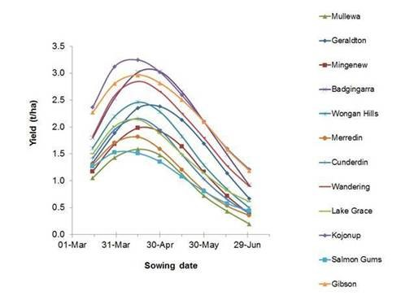
In summary if you haven’t sown canola yet then it is worth considering your options.
- If you have followed the David Ward canola theory of not sowing unless there is soil moisture, then you have the option of switching out of canola and back into a cereal
- If you have dry sown already, then there’s no need to ponder this but it may pay to ponder if canola emerges late June will it be better to re-sow the canola or legumes with cereals.
  - For canola sown without pre-emergent chemicals such as atrazine or propyzamide then re-sowing with cereals is an option
  - RR canola is generally sown for weed control and therefore is more likely to kept as a fallow with canola growing on it, though re-sowing to barley with high seeding rates might be more profitable
  - If canola has been sown with atrazine, then you will need to ponder at what time might it be more profitable to re-sow to barley if you are using RTK. You will need to discuss this with you agronomist as sowing into the existing row is essential to avoid crop damage
  - If canola has been sown with propyzamide, then re-sowing is unlikely to be a successful option as the propyzamide is likely to be too damaging to cereals

Wheat

Using wheat for a proxy for both wheat and barley the following chart can give an indication of sowing time frame that wheat or other cereals may become unprofitable

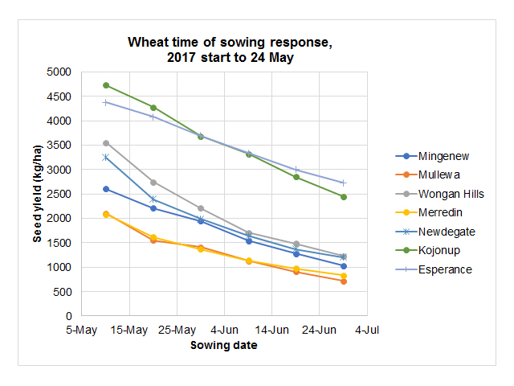
The chart indicates that in the low rainfall zone, cereals sown after the middle of June are unlikely to be profitable, however in high rainfall areas such as Esperance or Kojonup you are likely to still grow a profitable crop even sown as late as the first week of July.

From this data and long-term modelling only the low rainfall zones and perhaps the lower end of the medium rainfall zones that should consider leaving out cereals in favour of fallow. The medium and high rainfall zones will often still produce a crop that is more profitable than fallowing plus any benefit to the following crops the following year as the soil profile will often become fully wet during the growing season negating any stored water advantage to the following crop

Fallow

Fallow will not always result in increased yield in the following season, and the range of any increase in yield is large ranging from 0.00 t/ha through to 1.00 t/ha. Soil types that have limited capacity to store moisture such as; shallow gravels and deep sands when fallowed will only provide rotational weed control. For the low rainfall zone I will assume an average yield gain from fallow of 0.40 t/ha.

The first step in any decision to include fallow is to assess the break even on a variable cost basis, as outlined in the first table. You then need to work out an estimated cost for fallow I have used three sprays of $15.00 and three passes of the boom at $3.00 (cash cost) for a total cost of $39.00
Using Cash Costs - Break Even Yield to match Fallow
 | L | M | H
Total Variable Costs | 241 | 344 | 431
Less Fallow Cost | -43 | -43 | -43
Variable Cost Less Fallow | 187 | 290 | 377
Break Even Yield T/Ha | 0.73 | 1.14 | 1.48

For cash strapped business once the required breakeven yield is known you can then calculate your estimated crop yield. If the estimated yield is below the break-even, then fallow will be the best option to adopt.

If your business is in a stronger position, then the net effect of the fallow benefit can be considered in this case using 0.40 t/ha increase in yield for the following crop and a $255/farm gate wheat price.
Using Full Costs - Break Even Yield to match Fallow
Total Variable Costs | 241 | 344 | 431
Plus 0.40 T/ha @ $255 | 102 | 102 | 102
Gross Margin | 276 | 390 | 489
Break Even Yield t/ha | 1.08 | 1.53 | 1.92

It is worth noting that the $255 farm gate price is the 2020 price of wheat, so I have not calculated sensitivities though a $20 increase in Farm Gate price equate to around 100kg increase to breakeven yields.

Potential yields can be calculated using expected rainfall for the remainder of the growing season multiplying the result by 67%, to account for the evapotranspiration, and then multiplying the result by expected kg/mm

For example

200mm expected rainfall
200mmx 0.67 =134mm
130mm by 10kg = 1,340 kg or 1.34 t/ha

Though as the season gets later Water Use Efficiency declines as heat and vernalisation requirement reduce the plants potential therefore the later the emergence of crop the lower WUE number that should be used in the calculation as demonstrated in the following chart.
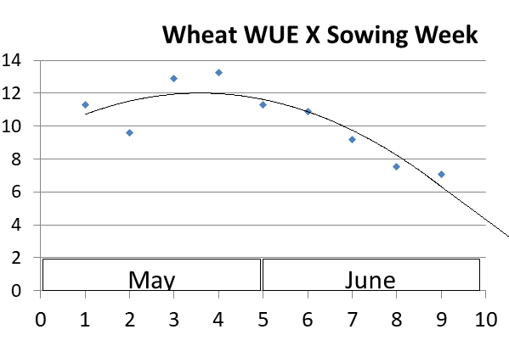

Oats may not be well suited to running though to grain production if the season is late as grain yields will be low and grain weights may not meet milling requirements.
Oats if planted do potentially have a place for hay production or can be sprayed out and used for grazing later in the season. Both hay and grazing could give a disease and weed break rather than a higher cost barley or wheat crop.

Sowing late in the season with an early maturing variety may lead to the following for grain:
- The crop will be lower yielding but will have higher grain protein because it will flower and fill the grain later in spring when moisture is likely to be limiting and temperatures are higher.

Late Season Decisions

If the season is unfavourable then the decision to spray out or run the crop through to harvest will need to be considered, at this time all past costs will be considered as sunk costs and the options will be considered based on the outcome from that time onward.

The consideration will come down to the cost of harvest and past experience suggests that the rule of thumb is 200kg/ha of wheat will be required to cover the cost of harvest and any costs prior to harvest will need to yield at 200kg/ha plus the yield required to cover the cost of the operation plus input being considered.

The calculated canola break-even yield may be lower but to effectively harvest a canola crop experience has shown that it needs to yield above 150kg/ha.

To compare the option of taking canola through to harvest or whether it should be sprayed out we need to allow for an insecticide application as well as a desiccation spray. Canola in stressed conditions is likely to attract heavy insect pressure and will still need an application of insecticide despite the low potential yield and therefore needs to include a higher chemical cost.

Breakeven Yields
Crop | Wheat | Barley | Canola | Lupins
Farm Gate Price | $265 | $215 | $510 | $300
Cash Only Costs
Extra chemical and application above Blowing out with Glyphosate | $15 | $20 | $50 | $20
Harvest Cost | $15 | $15 | $20 | $15
 | $30 | $35 | $70 | $35
Break Even Yield for Cash Costs | 110kg | 160kg | 140kg | 120kg
Full Costs including depreciation
Extra chemical and application above Blowing out with Glyphosate | $20 | $25 | $55 | $25
Harvest Cost | $25 | $20 | $25 | $20
 | $45 | $45 | $80 | $45
Break Even Yield for Full Costs | 170kg | 210kg | 160kg | 150kg

Summary

In summary we are now facing a later than average break to the season therefore it is likely that crop yields will be below long-term averages especially on very heavy soil types

Canola and legumes have a lower probability of producing profitable yields with late starts and low potential rainfall therefore any future planting should be carefully considered.

Cereals and wheat in particular still have a good probability of generating profitable yields especially in the medium and high rainfall zones.

In medium rainfall and high rainfall zones paddocks where growers have livestock, paddocks with low yield potentials should be left out to pasture especially those paddocks with high weed burdens.
In the low rainfall zone it is too late to sow profitable canola and legume crops. Only continue planting cereals on clean paddocks that are likely to germinate on minimal rainfall i.e. good sandplains.

High weed burden paddocks and heavy soil types can be considered for fallow.

